Name: FRANCIS SAKALA
Roll No: 25/SCA/BCAC/024
Subject: 4.5CA101C01H WEB TECHNOLOGIES
Assignment 1

- Biodata html
<html>
<head>
<title>Biodata</title>
<link rel="stylesheet" href="Biodata_25SCABCAC024.css">
</head>
<body>
<h1>Enter your information</h1>
<table border="1">
<tr>
<td>Name</td>
<td><input type="text" id="name"></td>
</tr>
<tr>
<td>Address</td>
<td><input type="text" id="address"></td>
</tr>
<tr>
<td>date of birth</td>
<td><input type="text" id="date"></td>
</tr>
<tr>
<td>email</td>
<td><input type="email" id="email" placeholder="jubi@gmail.com"></td>
</tr>
<tr>
<td>Mobile</td>
<td><input type="text" id="number"></td>
</tr>
<tr>
<td>Gender</td>
<td>M<input type="radio" name="gender">
F<input type="radio" name="gender">
</td>
</tr>
<tr>
<td>Hobby</td>
<td><input type="text" id="Hobby"></td>
</tr>
<tr>
<td>Skill</td>
<td><input type="skills" id="skills"></td>
</tr>
<tr>
<td>Languages</td>
<td><input type="text" id="Languages"></td>
</tr>
<tr>
<td>Achievements</td>
<td><input type="text" id="skills"></td>
</tr>
<tr>
<td>Qualification</td>
<td><input type="text" id="Qualification"></td>
</tr>
<tr>
<td>Comments</td>
<td><textarea>Write here</textarea></td>
</tr>
</table>
</body>
</html>
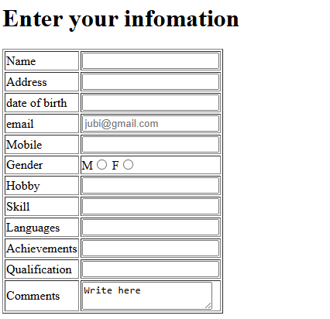
2.CSS
